 Soil Health Assessment Project Regional Region

Producer Report

Thank you for being a participant in our California Farm Demonstration Network assessment of soil health indicators. This work would not be possible without your collaboration and input. Our goal is to refine what tools are useful to track soil functions, compare the results from in-field and lab testing methods, and understand which tests respond to management differences. At the end of this study, we plan to have the following outputs:

**1)** A list of recommended in-field soil health assessment tools for farmers in California.

**2)** The results from in-field and lab assessments

**3)** A personalized report about your soil

**4)** The foundation of a soils database needed to develop benchmarks for regions across the state.

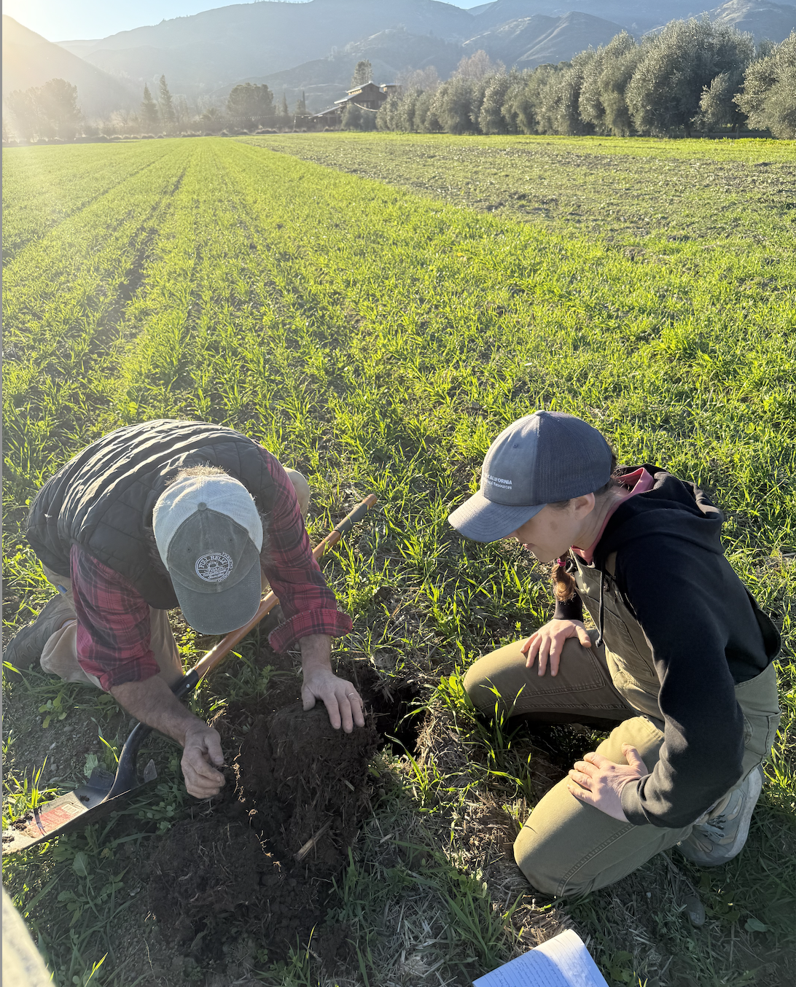

**Things to keep in mind with this report:**

**1)** For each indicator, you will see two fields listed. These are the fields selected for comparison.

**2)** The soil results for each of your fields may not reflect the impacts of recent soil management changes. Using comparisons on your farm and taking tests over multiple years is the best way to track the long–term status of your soil.

## Soil Health Indicators

Soil health is a term that describes how well a soil ecosystem supports plants, animals, and humans. It also recognizes the living nature of soils and the importance of soil microorganisms. Healthy soils can provide wildlife habitat, support biodiversity, reduce the effects of climate change, filter air and water, increase crop productivity and food security, and ensure thriving rural economies.

## Soil Health Indicators

The below table describes: 1. What each indicator helps measure in your soil; 2. Whether you want the measured value to be higher (more is better), lower (less is better), or in the middle (optimal range); and 3. How often to measure each indicator. Our understanding of these indicators is rapidly evolving as researchers measure them in diverse soils, cropping systems, and climates.

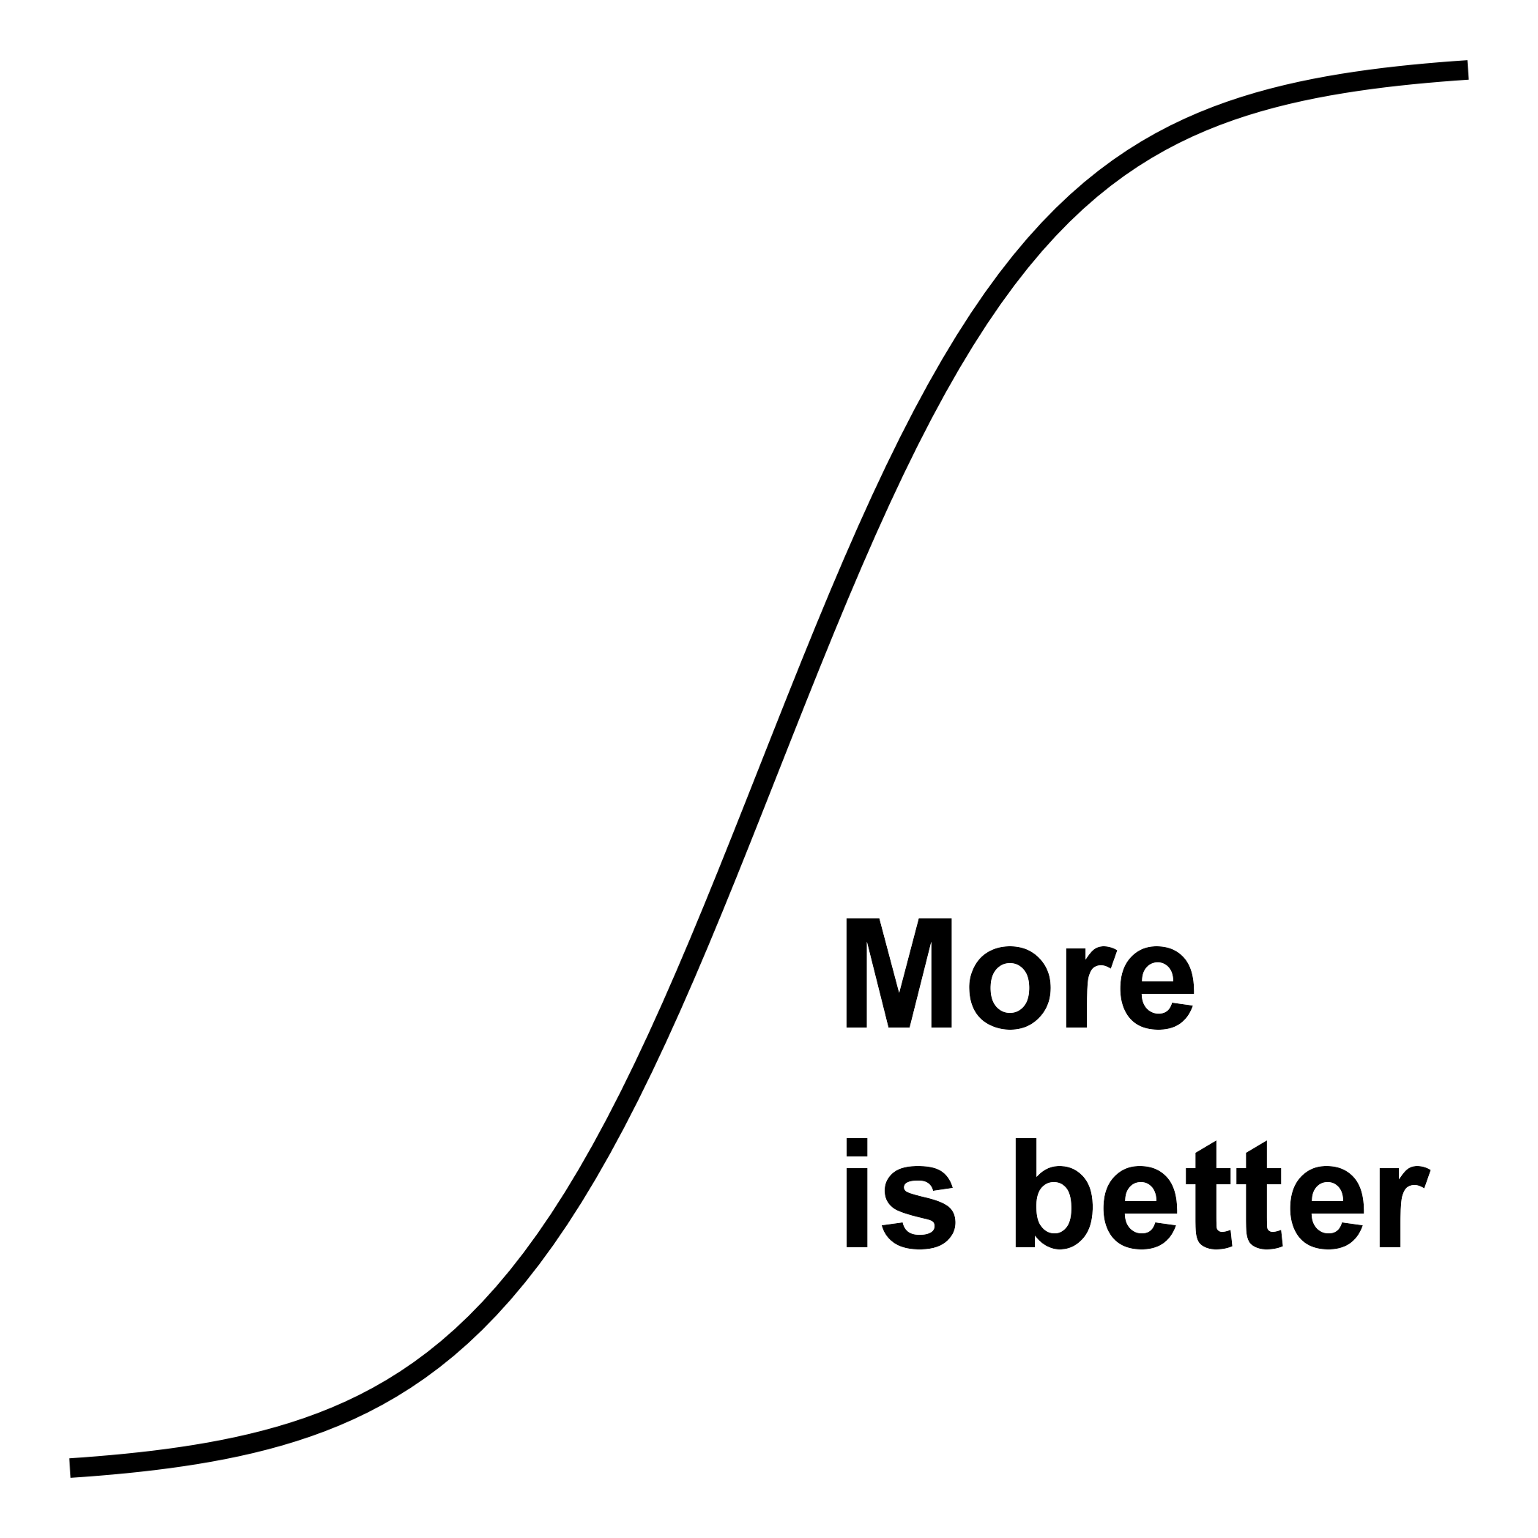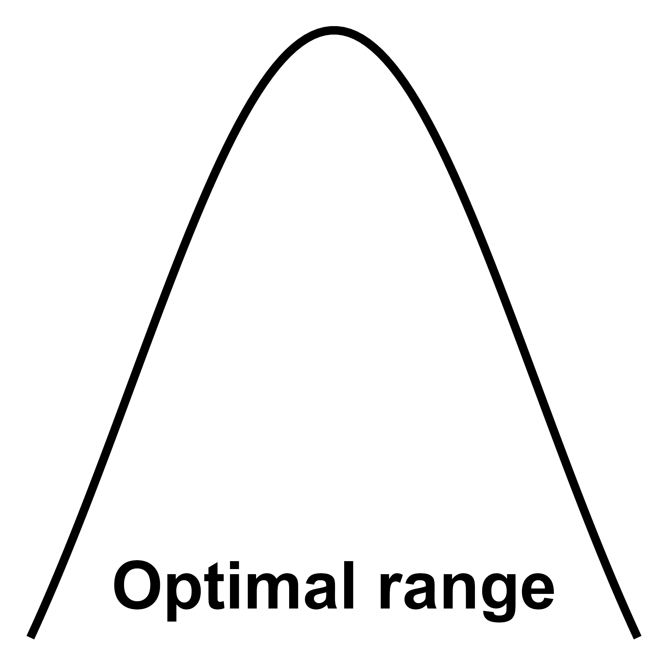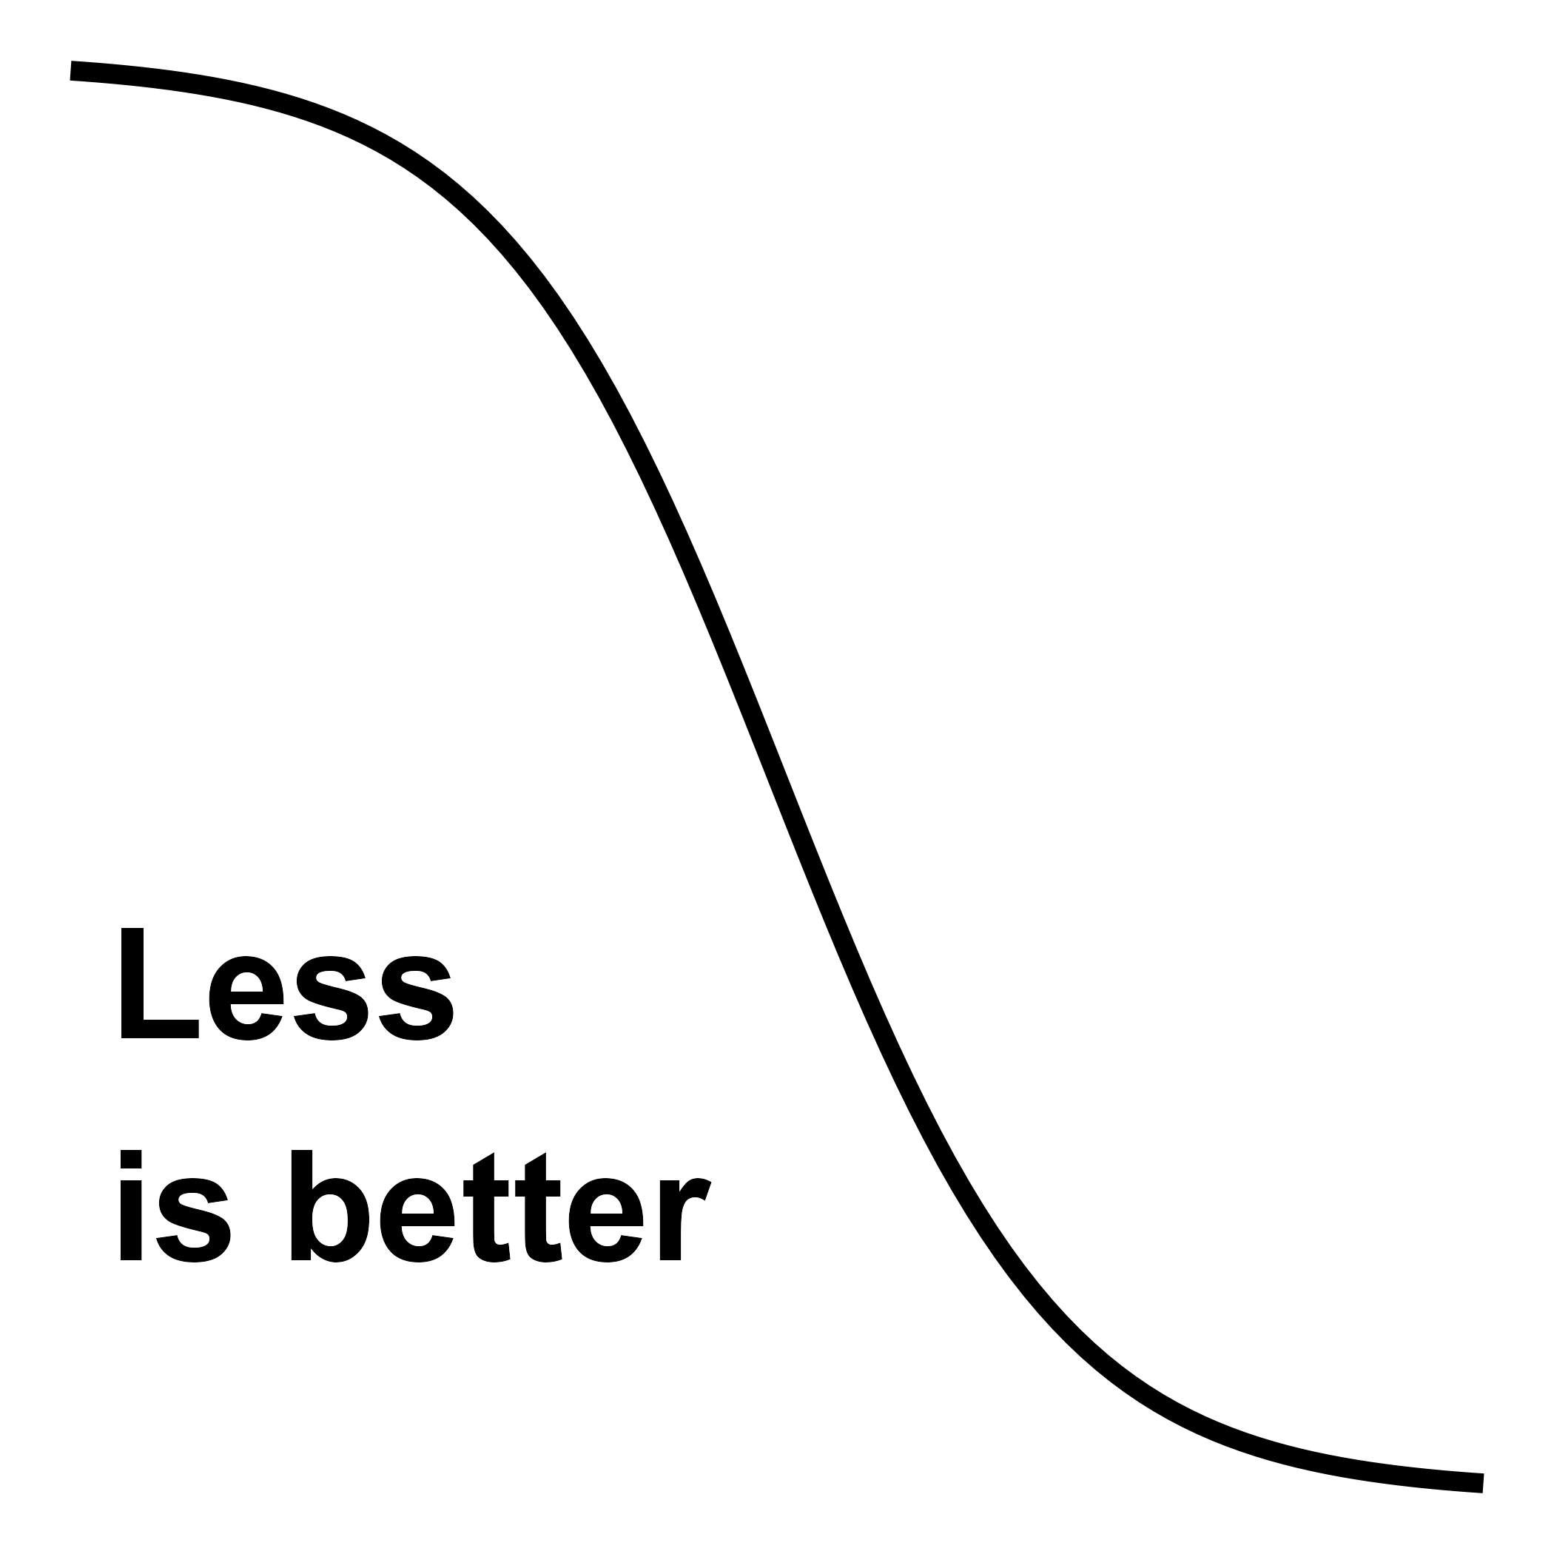

| **Indicator** | **Description** | **More_is_Better** | **Measurement_Frequency** |
| --- | --- | --- | --- |
| **character** | **character** | **character** | **character** |
| **Organic Matter** | Measures the amount of decomposed plant and animal material in soil | Yes | Annually |
| **pH** | Measures soil acidity or alkalinity | Optimal Range | Every 2-3 years |
| **Cation Exchange Capacity** | Measures soil's ability to hold and exchange nutrients | Yes | Every 3-5 years |
| **Bulk Density** | Measures soil compaction and porosity | No | Every 2-3 years |
| **Aggregate Stability** | Measures soil structure and resistance to erosion | Yes | Every 2-3 years |
| **Infiltration Rate** | Measures how quickly water enters the soil | Yes | Every 2-3 years |
| **Available Water Capacity** | Measures soil's ability to store water for plants | Yes | Every 3-5 years |
| **Nitrogen** | Measures available nitrogen for plant growth | Optimal Range | Annually |
| **Phosphorus** | Measures available phosphorus for plant growth | Optimal Range | Every 2-3 years |
| **Potassium** | Measures available potassium for plant growth | Optimal Range | Every 2-3 years |
| n: 20 | | | |

### Qualities of a Healthy Agricultural Soil

* GOOD DRAINAGE, MINIMAL FLOODING: soil physical structure that allows water to move efficiently is key to healthy soil.
* RESISTANT TO DEGRADATION: related to good drainage, a healthy soil will have good aggregation that resists water and wind erosion and runoff.
* THRIVING SOIL LIFE: these include both micro- and macroorganisms in the soil which help to build healthy soil and require soil pore space and organic matter additions to thrive and facilitate nutrient cycling.
* NO RESIDUAL CHEMICALS: efficient nutrient cycling and avoiding the accumulation of toxins that could harm a crop, such as salts.
* HEALTHY, PRODUCTIVE CROPS: this is a result of the qualities listed above that support crop growth with minimal inputs and with minimal disease.

## Your Fields

| **Treatment ID** | **Longitude** | **Latitude** |
| --- | --- | --- |
| **No-till** | -122.2155 | 38.8637 |
| **No-till** | -122.2155 | 38.8637 |
| **No-till** | -122.2155 | 38.8637 |
| **No-till** | -122.2155 | 38.8637 |
| **No-till** | -122.2155 | 38.8637 |
| **Standard till** | -122.2136 | 38.8622 |
| **Standard till** | -122.2136 | 38.8622 |
| **Standard till** | -122.2136 | 38.8622 |
| **Standard till** | -122.2136 | 38.8622 |
| **Standard till** | -122.2136 | 38.8622 |

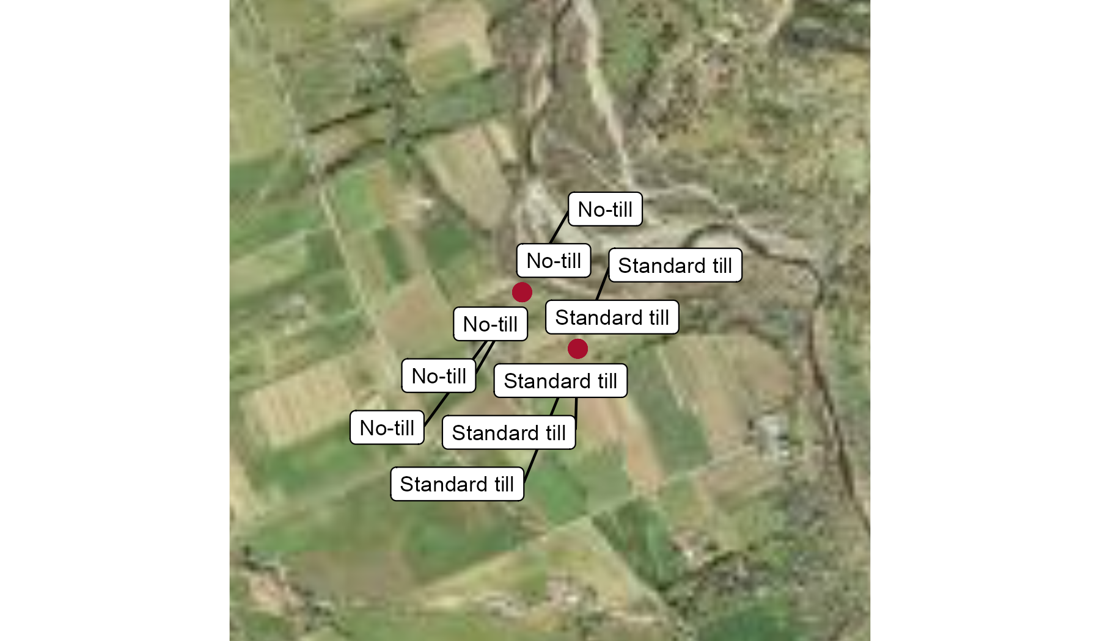

## Project Results

For the project we took soil samples from your selected fields using the grouping variable “{{ params$grouping_var }}”. You can see the GPS locations of your fields above. The other data included in this report are from other fields in the project for comparison.

The results below are organized into tables and graphs describing the physical, chemical, carbon, and biological measurements from your soils. Each point represents an average of the five samples we collected from each field. All samples that were sent to the lab were collected from 0-6 inches depth, while in-field soil measurements were collected from a 6-8 inch hole. ***All in-field indicators are marked with an asterisk (*).**\*

### Physical

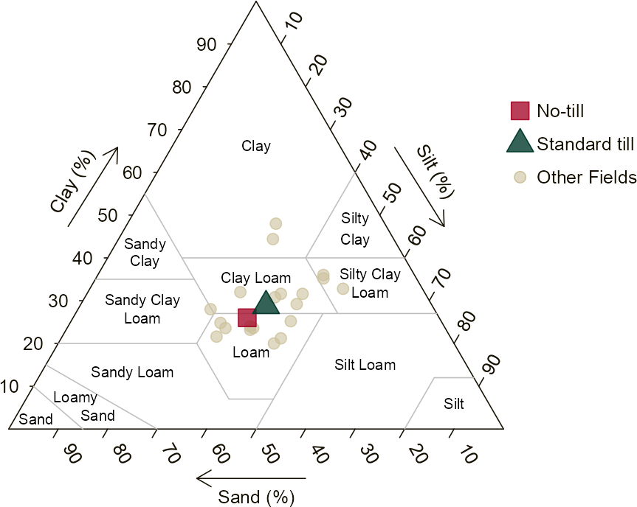

| **Field or Average** | **Texture** | **Sand** | **Silt** | **Clay** | **Water Stable Agg.** | **Agg. Stability Index\*** | **Infiltration 1st inch\*** | **Infiltration 2nd inch\*** |
| --- | --- | --- | --- | --- | --- | --- | --- | --- |
|  | | **%** | | | |  | **sec/1 inch water** | |
| **No-till Average  (5 Fields)** | LOAM | 39 | 35 | 26 | 23 | 0.70 | 23 | 48 |
| **Standard till Average  (5 Fields)** | CLAY LOAM | 34 | 38 | 29 | 33 | 0.53 | 44 | 260 |
| **Project Average** |  | 33 | 38 | 29 | 41 | 0.47 | 570 | 420 |
| Values ≥ project average have darker backgrounds.  Values < project average have lighter backgrounds. | | | | | | | | |

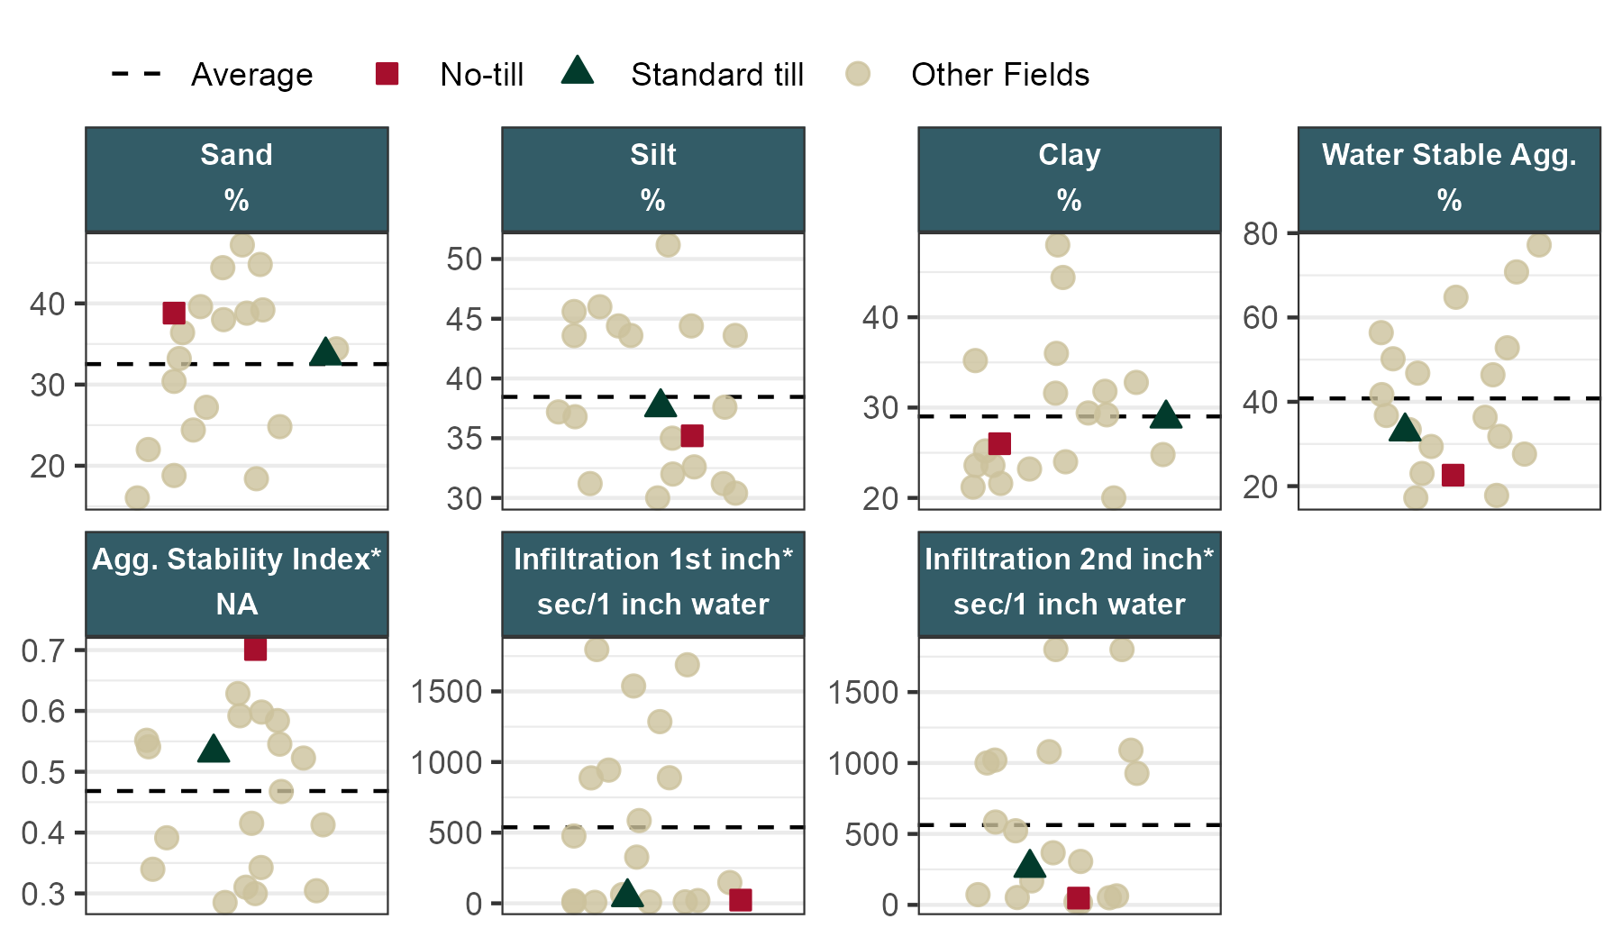

### Chemical

| **Field or Average** | **pH** | **CEC** | **P** | **K** | **Ca** | **Mg** | **Total N** | **PMN - 28 days** | **NO3-N** | **Nitrate Quick Test\*** |
| --- | --- | --- | --- | --- | --- | --- | --- | --- | --- | --- |
|  | | **cmolc/kg** | **ppm** | | | | **%** | **ppm** | | |
| **No-till Average  (5 Fields)** | 7.6 | 32 | 200 | 560 | 4,300 | 1,000 | 0.21 | 31 | 2.9 | 5 |
| **Standard till Average  (5 Fields)** | 7.7 | 35 | 210 | 490 | 5,100 | 1,000 | 0.20 | 21 | 1.4 | 5 |
| **Project Average** | 7.3 | 33 | 150 | 550 | 4,000 | 1,300 | 0.25 | 28 | 3.9 | 17 |
| Values ≥ project average have darker backgrounds.  Values < project average have lighter backgrounds. | | | | | | | | | | |

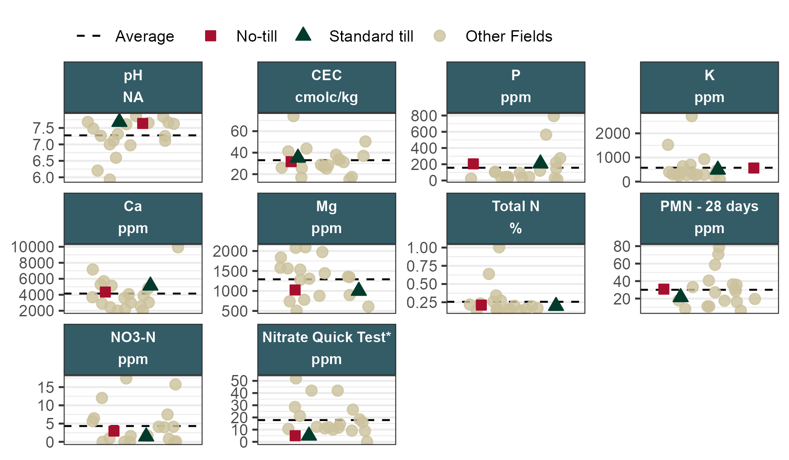

### Carbon

| **Field or Average** | **Total C** | **Organic Matter** | **Soil Respiration** | **POXC** |
| --- | --- | --- | --- | --- |
|  | **%** | | **ug/g/day** | **ppm** |
| **No-till Average  (5 Fields)** | 2.2 | 4.4 | 38 | 560 |
| **Standard till Average  (5 Fields)** | 1.9 | 3.9 | 46 | 490 |
| **Project Average** | 2.5 | 5.1 | 61 | 480 |
| Values ≥ project average have darker backgrounds.  Values < project average have lighter backgrounds. | | | | |

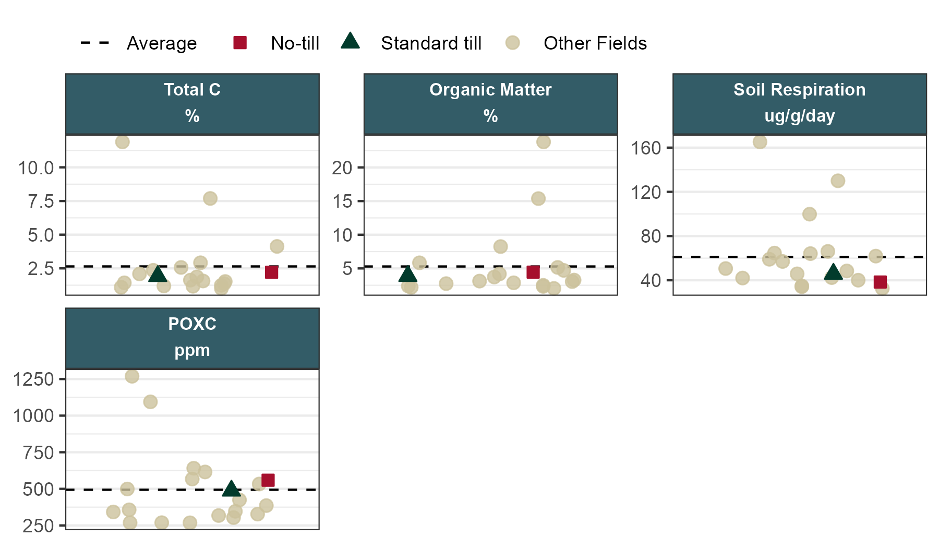

### Biological

| **Field or Average** | **Micr. Biomass** | **Bact. Biomass** | **Fung. Biomass** | **AMF Biomass** | **Fungi:Bacteria** | **Prot. Biomass** | **Undiff. Biomass** | **Biopore Count\*** | **Invert. Count\*** |
| --- | --- | --- | --- | --- | --- | --- | --- | --- | --- |
|  | **ng/g** | | | |  | **ng/g** | |  | |
| **No-till Average  (5 Fields)** | 6,700 | 3,200 | 1,100 | 300 | 0.35 | 160 | 2,200 | 15.0 | 0.4 |
| **Standard till Average  (5 Fields)** | 5,300 | 2,500 | 790 | 180 | 0.32 | 98 | 2,000 | 5.6 | 0.4 |
| **Project Average** | 7,700 | 3,500 | 1,200 | 280 | 0.36 | 180 | 2,700 | 7.5 | 1.3 |
| Values ≥ project average have darker backgrounds.  Values < project average have lighter backgrounds. | | | | | | | | | |

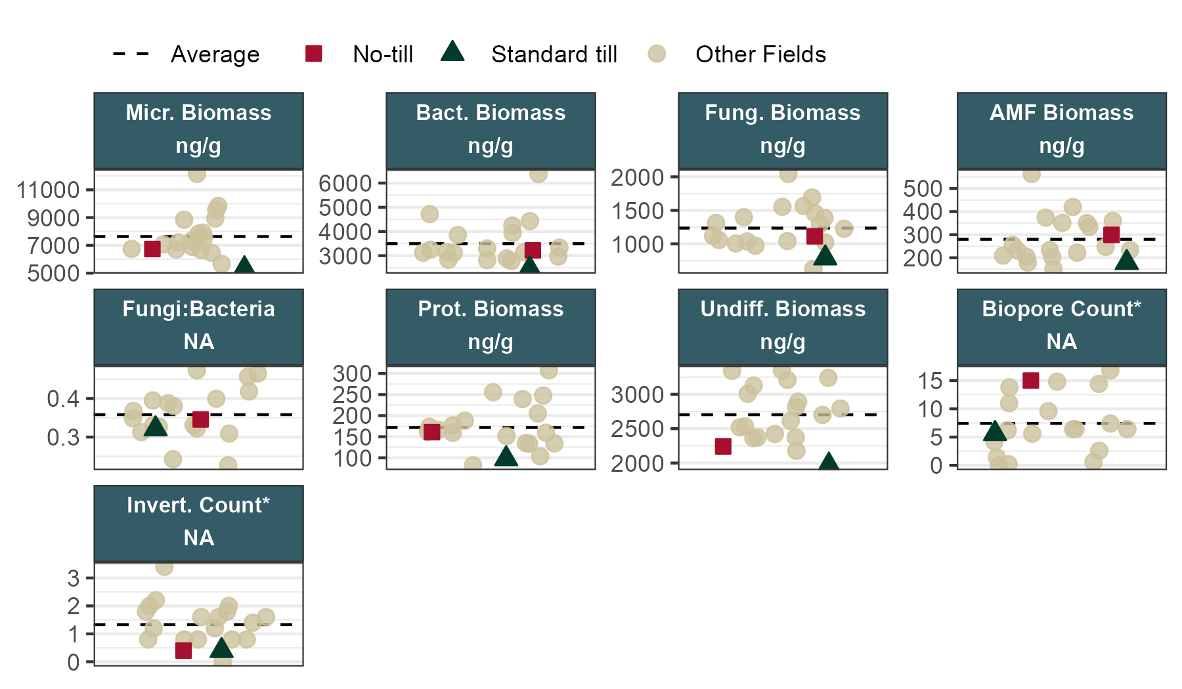

## Looking Forward

Thank you again for your participation in our project, and for your patience as we prepared these results. The next phase of our work will be to analyze which indicators are most sensitive and informative of the management and performance differences that farmers describe. We will share these results with you as we develop them in fall 2025. We also plan to continue refining our understanding of the efficacy and sensitivity of soil health indicators in various cropping systems of California and to continue sharing that information with farmers.

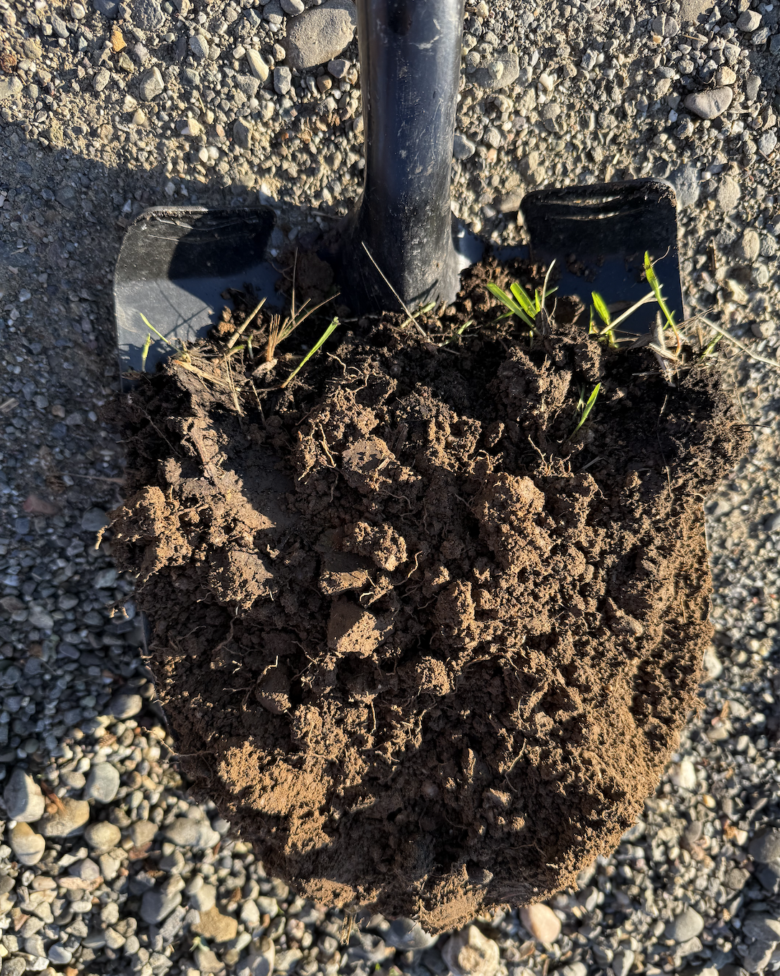

## Acknowledgement

This report was generated with the {casoils} R package, developed for UC Agriculture and Natural Resources (UCANR) and the California Farm Demonstration Network.

{casoils} builds upon the {soils} package, created by the Washington State Department of Agriculture and Washington State University as part of the Washington Soil Health Initiative.

Special thanks to Peter Geoghan from the Gaudin Soil Agroecology Lab for sharing his adaptation of the WASHI code with us and answering questions about generating reports. Text describing the in-field indicators was adapted from the NRCS Cropland In-Field Soil Health Assessment Guide (Technical Note No. 450-06 Jan 2021).

The soils collection and analysis for this report was supported by funds from the Climate Action Research Grants Program of the University of California, Grant # R02CP6986.

## Indicator Reference List

## **Physical**

***Soil Texture*** is the relative proportion of sand, silt, and clay-sized particles in your soil. Imagine these particles like basketballs, golf balls, and poppy seeds, which are very different in size even though soil particles don’t appear different to the naked eye. Importantly, soil texture describes only the mineral portion of the soil, which cannot be changed through management. However, soil texture is a significant driver of how soils respond to management. Soils with higher clay content can hold more nutrients, organic matter, and water than sandy soils. This is because clay particles have high surface area and electrical charge that create small soil pores and a “holding capacity”. Soils with high sand content have larger pores, and cannot hold as much water.

Soil texture was measured via hydrometer, after the removal of larger (>2mm) soil particles.

***Wet Aggregate Stability*** measures the resistance of soil aggregates to disintegration. Aggregates form when soil particles associate with organic matter, plant roots, fungal hyphae, and “glues” made by soil microbes; this shows how biological life in the soil impacts soil physical properties. Stable aggregates can reduce erosion, and increase infiltration, drainage, and storage capacity. High clay soils tend to have higher aggregate stability, but increasing soil organic matter improves aggregate stability across all soil textures.

Aggregate stability was measured two ways: 1) the percentage of 0.25-2.00 mm aggregates that stay intact after exposure to artificial rain. A higher value means that a greater percentage of the soil remained aggregated. 2) For the in-field measurements, we collected intact soil aggregates, dried them for at least 24 hours, and then measured their disintegration when submerged in water using the camera function as part of the SLAKES App. The results of this app provide an Index score from ~0.1 to 1.0; a higher number indicating greater aggregate stability.

***Infiltration Rate*** measures the rate at which water enters the soil surface. Texture, salinity, plow pans, and soil structure drive water movement in the soil. Infiltration is supported by soil movement and aggregation by ecosystem engineers (ants, earthworms, enchytraeids) and plant roots and fungal hyphae.

In this assessment, infiltration was measured in-field by timing how long it took for a first and second inch of water to infiltrate into the soil profile using a single ring infiltration test, with a cut-off time of 30 minutes.

## **Chemical**

***Soil pH*** measures how acidic (pH less than 7.0) or alkaline (pH greater than 7.0) the soil is. The pH level impacts the availability of plant nutrients as well as which microbial population can live in soil, which is important for nutrient cycling. Soil pH is impacted by inherent soil qualities such as age, mineralogy, and rainfall zone. It is also impacted by amendments, irrigation water pH, and SOM content. Most agricultural crops grow best in a pH range of 6 to 8.

In this assessment, pH was measured by mixing soil and DI water in a 1:1 or 1:2 ratio (depending on texture) and measured using a pH probe.

***Cation Exchange Capacity*** (CEC) describes the soil’s ability to hold a slow-release reservoir of nutrients, as positively charged ions (e.g., NH4+, K+, Ca2+, Mg2+) in the soil are held by negatively charged sites on clay particles and SOM. While CEC is determined in part by soil texture, increasing SOM can greatly increase CEC. Sandy loam soils typically have CECs ranging from 1 to 10 meq/100 g, loam soils range from 5 to 15 meq/100 g, and clay soils have CECs greater than 30 meq/100 g. SOM can provide an additional 200 to 400 meq/100 g (note that CEC units may be reported differently, but 1 meq/100g = 1 cmolc/kg). Soil pH can also alter the CEC of organic matter and clay particles, further underscoring the impact of pH on other soil measurements.

CEC was calculated in this assessment as the sum of the base cations Ca2+, Mg2+, and K+. Other assessments also include Na+, so this result may look different than the results from other labs.

***Essential Plant Nutrients*** measures the concentration of macronutrients such as nitrogen (N), phosphorous (P), potassium (K), calcium (Ca), magnesium (Mg), and sulfur (S), and micronutrients (required in comparatively smaller amounts) such as iron (Fe), zinc (Zn), copper (C), boron (B), and manganese (Mn) in a soil solution. These elements are typically reported in parts per million (ppm), which is equivalent to milligrams per kilogram (1 ppm = 1 mg/kg). Each of these elements are required for crop production. The quantity, timing, placement, and source of each nutrient will vary depending on the crop. While many of these nutrients are inherent in the soil, some must be added. Careful consideration should be given to balancing and replenishing plant essential nutrients via soil health building practices and principles. More information on plant essential nutrients can be found in the Oregon State University Soil Test Interpretation Guide (available via online search).

Essential plant nutrients were measured using the Mehlich 3 reagent, which is a chemical solution engineered to mimic how plants extract nutrients from the soil. The results are not indicative of the total pool of this nutrient in the soil, but rather a benchmark that can be used to calibrate fertilization and other management.

***Total Nitrogen*** (TN) measures all the nitrogen in a soil sample, which includes both inorganic (nitrate and ammonium) and organic nitrogen. Most of the nitrogen is soil not immediately available for plant use, but rather, is the pool that is potentially available to microbes, who can cycle it within the soil and make it available to plants. Sufficient total nitrogen in the soil is key for promoting mineralization, the process of changing the organic nitrogen to a form. Total N is not used for fertilizer calculations, but can be used with Total Carbon to calculate the C:N ratio of the soil. Agricultural soils usually have an ideal C:N of 10:1. Higher C:N can lead to nutrient immobilization while lower C:N can lead to environmentally harmful N losses.

In this assessment, TN was measured by dry combustion, in which a soil sample is heated to a high temperature (min. 950°F) in order to convert the inorganic and organic portions of the soil into gases which are captured and measured by an infrared (IR) detector.

***Potentially Mineralizable Nitrogen*** (PMN) represents the amount of organic nitrogen that can be converted (or “mineralized”) to plant-available nitrate or ammonium. This measurement is taken from a laboratory incubation and can help producers estimate how much nitrogen may be released to crops during the growing season. Additional information on the measurement and interpretation of PMN can be found in the NRCS Soil Quality Indicator fact sheet on Potentially Mineralizable Nitrogen (available via online search).

In this assessment, PMN was measured as the total mineral N in a soil solution after a 28-day aerobic incubation period.

***Soil nitrate*** is a measurement of the nitrogen in a soil solution that is in nitrate form. Nitrate is the most plant-available form of N and indicates immediate soil fertility. Excessive soil nitrate is a concern because nitrate is water-soluble and can pollute water waterways if it is not taken up by plants. Low nitrate concentration may indicate low soil fertility, or a tight nutrient cycle in which nutrients are taken up by plants or microbes at a similar rate to mineralization.

In this assessment, nitrate was measured by a colorimetric determination after extraction from soil using a salt solution.

***Nitrate Quick Test*** assess the concentration of plant-available nitrates in a soil solution. Nitrate is the main form of nitrogen that plants use (the others are ammonium and small organic N compounds) and measuring concentrations in topsoil can provide useful real-time information about field fertility status.

In this assessment we measured nitrate by a field soil with a dilute CaCl solution in a 1:4 ratio, then shaking for 2 minutes, allowing it to settle for 2-5 minutes, and then dipping a test strip into the liquid and comparing the color development to the guide on the text strip bottle.

## **Carbon**

***Total carbon*** (TC) measures the total carbon in soil, which is predominantly soil organic carbon (SOC). SOC is a major component of SOM that drives the soil food web, serving as energy for microbial and other biological activity. It also plays a major role in other soil physical and chemical properties, such as aggregation and nutrient availability, respectively. It is derived from amendments, decomposing plant/root materials, macrofauna, etc. Soil inorganic carbon (TIC) is the fraction of TC that is formed from the soil parent material and the reaction of soil minerals with atmospheric CO2. TIC is primarily found in the soil as carbonates.

Total carbon was measured via combustion, in which a soil sample is heated to a high temperature (min. 950°F) in order to convert the inorganic and organic portions of the soil into gases which are captured and measured by an infrared (IR) detector.

***Soil Organic Matter*** (SOM) is the portion of soils composed of animal, plant, and microbial matter in various stages of decomposition. It excludes soil minerals, air, and water. SOM underlies many of the benefits and ecosystem services that soils provide. It has a large impact on almost all other soil properties and is often used as a primary indicator of soil health. SOM is composed of approximately 58% organic carbon. The remaining portion of SOM includes other essential plant nutrients such as nitrogen, phosphorus, and sulfur. SOM content varies by inherent soil and landscape properties such as texture, mineralogy, precipitation, and temperature. It is also greatly impacted by management. However, SOM can be slow to increase as the result of management. To learn more about how to increase SOM, read about the NRCS principles of building soil health.

The SOM results in this assessment are calculated values derived by multiplying total carbon (TC) x 2, following Pribyl 2010. The international standard calculation is to multiple SOC x 1.724, so these numbers might be higher than you are used to seeing.

***Soil Respiration*** (also referred to as “Potential Carbon Mineralization”) measures microbial activity via release of carbon dioxide (CO₂) from dry soil after being rewetted in laboratory conditions. Carbon mineralization is the process in which microbes produce CO₂ as they decompose SOM. During this process, other nutrients are also mineralized and made available to the crop for uptake. Soils with lower SOM will have inherently lower MinC, while compacted soils may not provide adequate aeration for the mineralization process. In this assessment, respiration was measured after 24 hrs and is reported as micrograms of CO₂ per gram of soil per day.

***Permanganate Oxidizable Carbon*** (POXC, also referred to as “Active Carbon”) is a measurement of soil carbon that is hypothesized to be influenced by changes in management (compared to SOM, which may not show changes in management for many years). POXC concentrations are associated with practices that lead to long-term organic matter storage, and may represent a portion of SOM that is from plant material, including compounds related to plant defense. In this assessment, POXC was measured by exposing dry soil to potassium permanganate, which is a strong oxidizer, and then measuring the color change of a soil solution as a result of the oxidation process.

## **Biological**

***Total Microbial Biomass*** is a measure of the total microbial community in the soil. Microbial biomass is a combination of bacteria, fungi, protozoa, and undifferentiated microbes, and forms a relatively small portion of the organic matter in soil. Despite being a small part of the soil, microbes are important indicators of soil functioning and nutrient cycling potential. Apart from nitrate fertilizer, most N that plants are able to use is first cycled through the microbial biomass in soil, i.e., that microbes ingest organic N and then when they die, that N is released into the soil in mineral form. Microbial biomass was measured via PLFA (phospholipid fatty acid) analysis, which entails extracting the phospholipids from soil, converting them to fatty acid methyl esters (FAMEs), and then analyzing them using gas chromatography.

***Bacterial Biomass*** is a measure of the amount of bacteria in soil. Bacteria are the basis of the microbial food web and they process most of the nutrients in soil. Bacteria tend to be the most dominant type of microbe in agricultural soils, and their abundance can vary widely at different time points in the year. This indicator was measured via PLFA, as described for Microbial Biomass (above).

***Fungal Biomass*** is a measure of the amount of fungi in soil. High fungal biomass, including arbuscular mycorrhizae (AM), is often an indicator of soil health, because fungi bind together soil particles, process nutrients, and can help soils be resilient to stress. Fungi will generally be less abundant than bacteria in agricultural soils.

***Fungi:Bacteria*** is the ratio of bacteria and fungi biomass in soil. While bacteria usually dominate in agricultural soils, a high ratio of fungi to bacteria is assumed by some to reflect greater soil health.

This indicator is calculated from Bacteria and Fungi biomass, which are measured via PLFA, as described for Microbial Biomass (above).

***Protozoan Biomass*** is a measure of the biomass of microbes in soil that are protozoa. Protozoa feed on bacteria and in the process, release nutrients into the soil. Their presence indicates that there are sufficient nutrient levels to support multiple levels of the soil food web. This indicator was measured via PLFA, as described for Microbial Biomass (above).

***Undifferentiated Microbial Biomass*** is a measure of the microbial biomass in soil that cannot be identified as one of the main three types of microbes (bacteria, fungi, protozoa). This pool is an important part of microbial biomass. This indicator was measured via PLFA, as described for Microbial Biomass (above).

***Biopores*** are the large and small holes left in soil by plant roots and soil organisms. Biopores are important for rapid air and water exchange and provide additional access to water and nutrients for new plant roots. Additionally, earthworm channels tend to be enriched with organic matter, microbes and nutrients. Biopores indicate both biological soil activity and also adequate soil structure. This indicator was measured using a golf ball sized aggregate of soil that was visually inspected to determine the number of biopores present.

***Visible Biodiversity*** is a count of the visible soil organisms in a shovelful of soil. Examples of observed organisms include earthworms, mites, springtails, millipedes, roundworms, beetles, ants, pill bugs, earwigs, and spiders. Soil organisms are important because they broadly influence all aspects of soil function including but not limited to aggregation, water dynamics, nutrient cycling, and pest suppression. Visible soil organisms also indicate the presence of small microorganisms within the soil food web.

This indicator was measured by digging a ~6-8 inch hole and then counting the number of different species in the dug up soil, as well as how many of each there were.